Creating Healthy Choices for Young Children

Unit 3

CE220-01 Child Safety, Nutrition, and Health

Name of Student

Date of Submission

Healthy Nutrition  for Young Children  The appropriate serving size for a toddle is approximately one-fourth of an adult in each food group.  Grains- 4 ounces  Vegetables- 1 1/2  Fruits - 1 1/2  Meat - 3 to 4 ounces  Five to seven years old children need the proper nutrition with more rigorous activities after completing their preschool years. To facilitate their learning, it is important that they are nourished appropriately on a daily basis, which also improves their growth (Marotz,2015). The age group defines little kids, who are still quite picky, but like indulging in their favorite foods.  The children in this group also tend to dislike certain foods. Advertising improves their perception on the importance of certain ingredients. |  | Creative Title  - Title of Your Learning Center  Healthy Choices for Young Children  Age 5 – 7
 |  | - Student Name

References

Abbey, Rodriguez. (2018).10 Creative & Healthy Snacks For Kids https://www.parenting.com/food-recipes/snacks/10-creative-healthy-snacks-kids?page=6
Common Sense Media. (2017). Is advertising harmful to kids? Retrieved from https://www.commonsensemedia.org/marketing-to-kids/is-advertising-harmful-to-kids#
Marotz, L. (2014). Health, safety, and nutrition for the young child (9thed). Stamford, CT: Cengage Learning.
UMass Extension Nutrition Education Program. (2018). Ants on a log. Retrieved from https://extension.umass.edu/nutrition/recipes/ants-log

Snack #1  Veggie and Pretzel Scooter  How fun is it to ride on a scooter? Now let’s use that fun in creating a healthy snack. To make, we will need pretzels, two toothpicks, string cheese, and cucumbers. Put them all together and VIOLA – you have a tasty veggie and pretzel scooter.  NOTE: Not appropriate for children under age 5 or those with specific food allergies.  Instructions  Cut four slices of cucumbers for wheels. Take a piece of string cheese and horizontally insert two toothpicks into each end. Slide the cucumber slices on the toothpicks for the wheels. Make a small hole in the top of the string cheese at one end and insert a pretzel stick into it. Use cream cheese to attach a second pretzel stick horizontally for the handlebars.  Nutritional Information  Calories in string cheese stick  Calories: 70  Fat: 2.5g  Cholesterol: 15mg  Sodium: 220mg  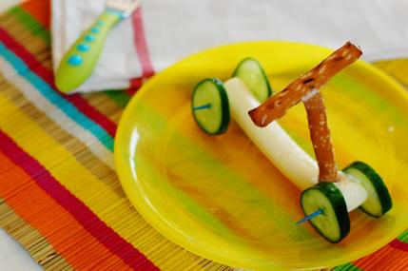  (UMass Extension Nutrition Education Program, 2018) | Do you love grapes? How about strawberries? Here is a fun and creative new idea on how to enjoy fruits. You can even prepare it yourself, and the best part is that you can use any available fruits. Today we’re going to use strawberries, seedless grapes, pineapple chunks, and skewers. Let’s get started on this fun new snack.  Note: Not appropriate for children under age 5 or those with specific food allergies  Instructions  After washing the strawberries and grapes, remove the leaves from the former, drain the pineapple, and cut the cheese in ½” cubes. Place two pieces of cheese and each kind of fruit on skewer, alternating fruit and cheese.  Nutritional Information  Serving size: 2 skewers  Calories: 160  Fruit and Vegetables: 2/3 cup  Fat: 9g  Fiber 1g  Sodium: 170 mg  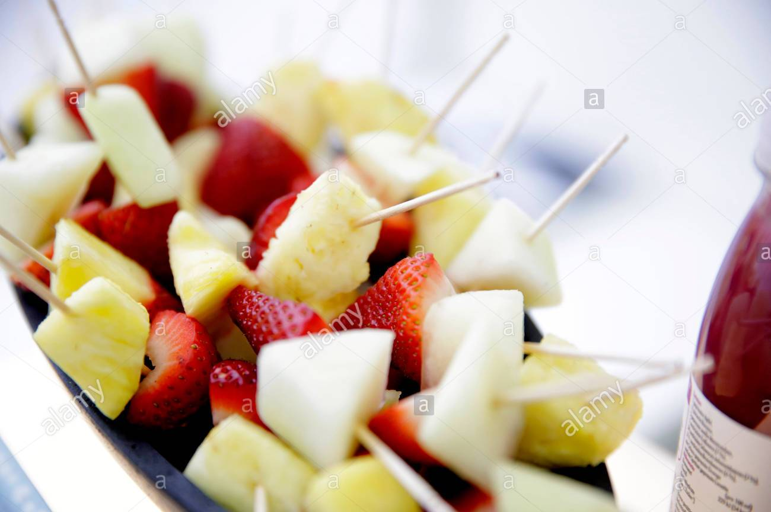  (UMass Extension Nutrition Education Program, 2018)  Snack #2  Fruit Kebabs | Snack #3  Butterfly Quesadilla  Quesadilla are awesome, but butterflies are much more awesome. So if you like butterflies, and love blueberries, carrots, and grapes, this is an amazing way to eat quesadilla. The best part is that you can make it all by yourself. Let’s get started on this delicious new and fun quesadilla.  Note: Not appropriate for children under age 5 or those with specific food allergies  Instructions  Create the wings with one quesadilla and cut into 4 equal portions. Place the wings on the plate. Then grab the grapes and create the body for the beautiful butterfly. Slice the baby carrots thinly to use as for antennae. Lastly, place two blueberries at the stop for the eyes.  Nutritional Information  Serving Size: 2 pieces  Calories: 218  Fat: 10g  Fiber: 5g  Sodium: 430mg  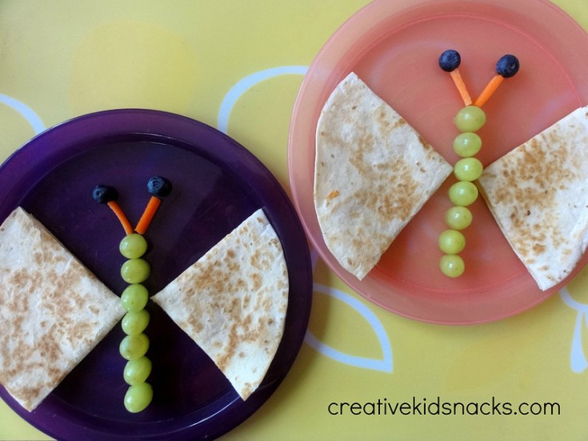  (Modern Families & Fresh ideas, 2018)

